Harder
Easier
1 | 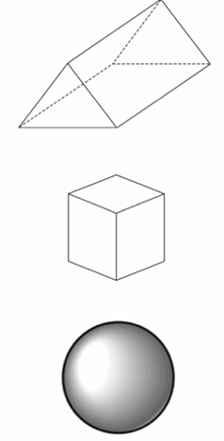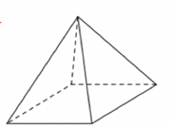  Write the names of each 3D shape beside it. | 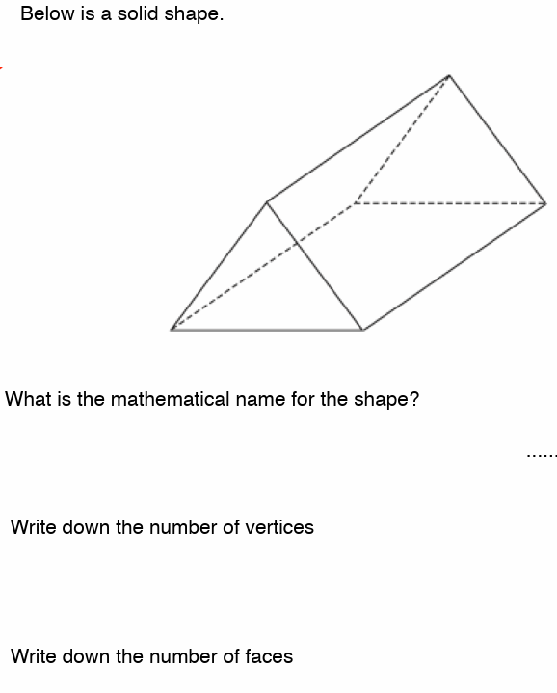  What is the name of the shape?......  How many vertices has it?.............  How many faces has it? …………… | 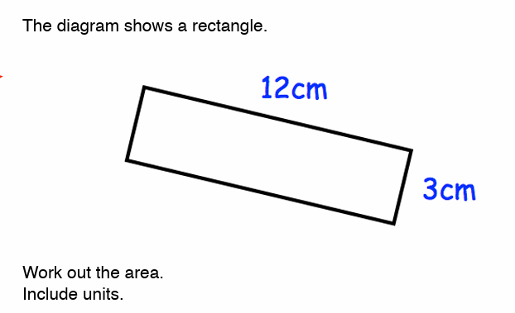  What is the area of the rectangle? Include units in your answer. | 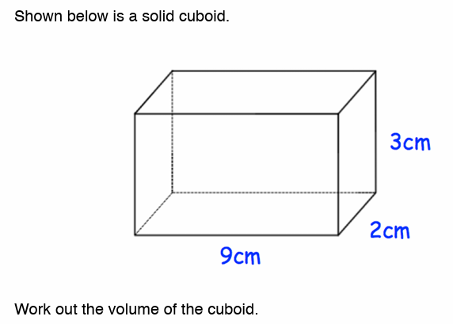  Work out the volume of the cuboid. Include units in your answer.
2 | Circle the shapes that are prisms.  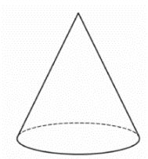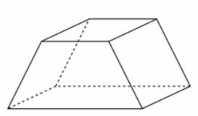  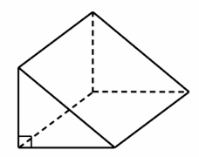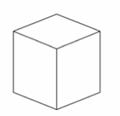 | 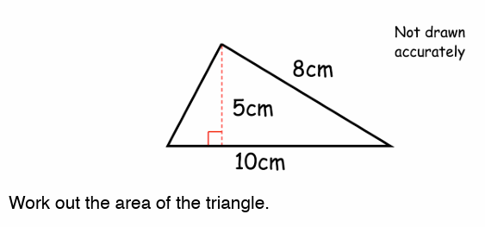  Work out the area of the triangle. | 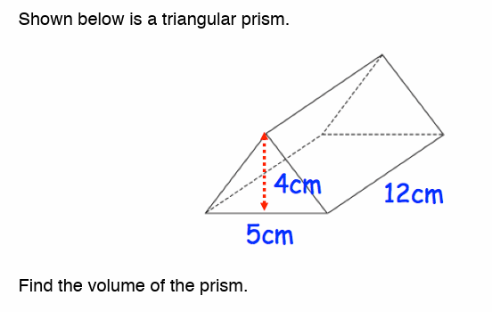  Find the volume of the prism. | 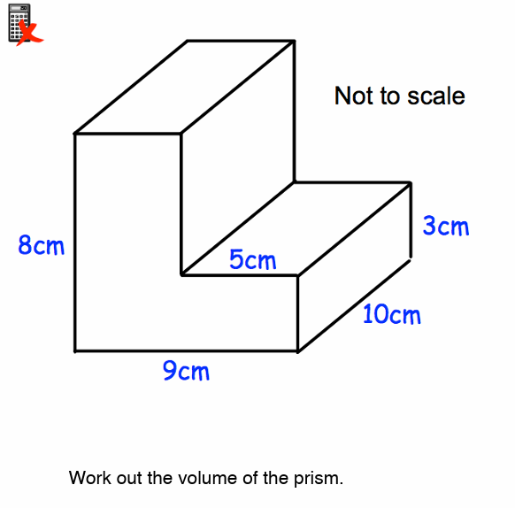Work out the volume of the prism.
3 | 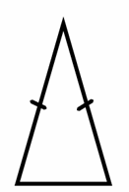………………………………..  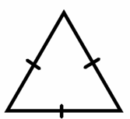………………………………  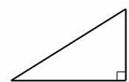………………………………  Label each triangle as equilateral, right angled or isosceles. | 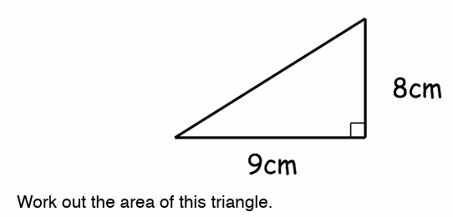  Work out the area of this triangle. | 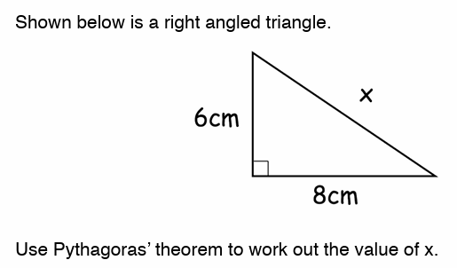  Use Pythagoras’ Theorem to work out the value of x. | 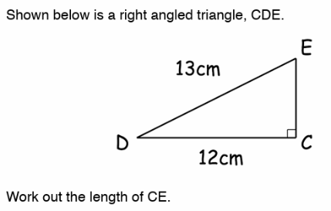  Shown above is the right-angled triangle CDE. Work out the length of CE.
 | RECALL
 | 425 + 699 | 748 - 487 | 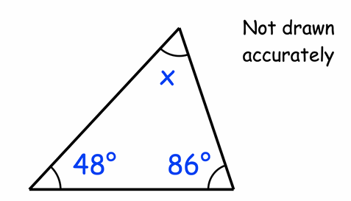  Work out the size of angle x?  x= | 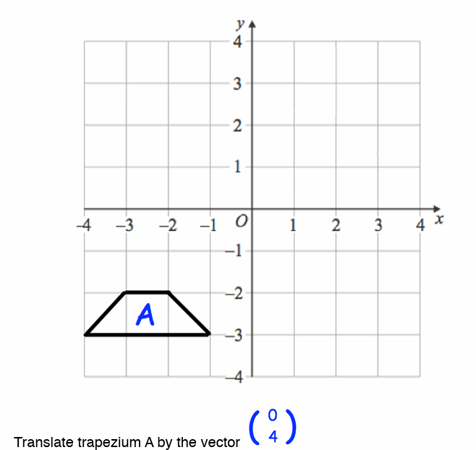  Translate the trapezium by the vector 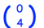
 | 17 x 21 | 453 $÷$ 5 | 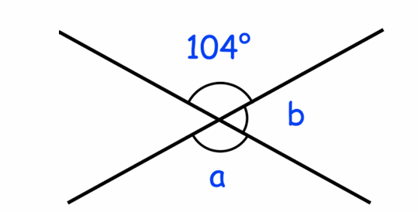  Work out the size of angle ‘a’ and ‘b’.  a= b=
 | Write down the ratio of squares to circles in its simplest form.  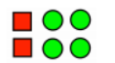 | Simplify the ratio 6:10 | Simplify:  4c + 3d -c |  | Expand the brackets:  3(y + 7) =
 | 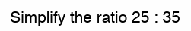 | 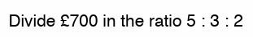 | Solve:  3 + 2x = 15 |  | Factorise:  4a² – 2a

